

Capstone Project Report
Report 1 – Project Introduction

– HoChiMinh, December 2026 –
Table of Contents
I. Record of Changes 3
II. Project Introduction 4
1. Overview 4
1.1 Project Information 4
1.2 Project Team 4
2. Product Background 4
3. Existing Systems 4
3.1 System name1 4
3.2 System name2 4
4. Business Opportunity 4
5. Software Product Vision 5
6. Project Scope & Limitations 5
6.1 Major Features 5
6.2 Limitations & Exclusions 6

I. Record of Changes
Date | A*  M, D | In charge | Change Description
06/09/2026 | A | Supervisor | Initial registration and approval of project concept.
21/09/2026 | M | VietNB | Updated proposed solutions: Added B2B/B2C token quota model and Classroom Group Lab mechanism.
06/10/2026 | M | VietNB | Refined Actor catalog matching B2B architecture (7 Roles) and distributed work packages.
18/10/2026 | M | HungNT | Updated Functional Requirements: Anti-Cheat seeded parameterization, account dispute governance, and curriculum topic hierarchy.
22/10/2026 | M | HungNT, VietNB | Finalized Project Introduction Report (Report 1): Completed Problem Background, Market Analysis, Product Vision, and Feature Tree.
28/10/2026 | M | HungNT | Refined Section 6 (Project Scope & Limitations): Explicitly demarcated Baseline Minimum Requirements (Core MVP) and Extended Production Scope per Academic Supervisor feedback.
*A - Added M - Modified D - Deleted

II. Project Introduction

1. Overview

1.1 Project Information
- Project name: PhysLive (Interactive Physics Simulation & AI-Assisted Problem-Solving Platform)
- Project code: FA26SE309
- Group name: GFA26SE173
- Software type: Web-based Educational Application (SaaS - Software as a Service)

1.2 Project Team
Full Name | Role | Email | Mobile
Nguyễn Hoàng Bảo Việt | Leader | Vietnhbse183457@fpt.edu.vn | 0966742773
Trần Bảo Minh | Member | MinhTBSE184103@fpt.edu.vn | 0971697740
Nguyễn Thế Hùng | Member | HungNTSE183807@fpt.edu.vn | 0399875082
Võ Trần Tuấn Kiệt | Member | KietVTTSE182808@fpt.edu.vn | 0379808938

2. Product Background
Physics is a foundational science that bridges abstract mathematical formalism with real-world empirical phenomena. However, in secondary education (particularly under Vietnam's 2018 General Education Curriculum - GDPT 2018), both educators and learners face significant systemic challenges:
- Abstract Conceptualization & Memorization Traps: Traditional pedagogical methods force students to memorize formulas and solve dry paper-based problems without observing the underlying physical mechanisms (e.g., oscillating spring-mass damping, electromagnetic induction, or wave superposition).
- Resource Constraints in School Laboratories: Physical laboratory apparatuses are expensive, fragile, difficult to calibrate, and carry safety hazards. Most schools lack the budget or scheduled hours to provide individual, hands-on experimental sessions for every student.
- Rigid Static Problem Sets: Homework problems in textbooks are static. Students often copy solutions from answer keys without genuine understanding. Teachers spend countless hours manually grading and lack modern tools to distribute parameterized, cheat-resistant variations.
PhysLive was conceived to overcome these bottlenecks. It is designed as an intelligent, AI-powered interactive sandbox where any natural-language physics problem can be automatically ingested, parsed into formal semantic specifications, rigorously verified against domain physics laws (energy conservation, Newton's laws), and converted into live, interactive 2D simulations in real time.

3. Existing Systems
3.1 PhET Interactive Simulations (University of Colorado Boulder)
- Description: The most well-known global open-source repository of interactive science simulations.
- Pros: Highly polished HTML5 animations, scientifically accurate, covers basic mechanics, waves, and electricity.
- Cons: Pre-baked and rigid. Users cannot type or paste an arbitrary textbook problem and expect PhET to generate a customized simulation. It provides fixed scenarios rather than an automated problem-solving pipeline.
3.2 Algodoo (Optimec)
- Description: A sandbox 2D physics drawing engine simulating rigid bodies, fluids, and optics.
- Pros: High creative freedom; fluid user interface for drawing mechanical contraptions.
- Cons: It is purely a sandbox without educational curriculum alignment, automated problem extraction, or classroom assignment governance. It does not parse physics problem statements.
3.3 GeoGebra Physics & Wolfram Alpha
- Description: Mathematical computation and geometric modeling tools.
- Pros: Exceptional symbolic computation and precise mathematical plotting.
- Cons: GeoGebra requires complex manual parametric scripting. Wolfram Alpha provides algebraic answers but lacks interactive, real-time kinetic simulations and classroom workflow management.
3.4 Competitive Advantage of PhysLive
Unlike existing systems, PhysLive uniquely bridges AI NLP extraction with verifiable physics simulation:
- Automatically extracts and validates textbook physics problems from raw text or photos using LLM/OCR.
- Provides Physics Law-Catalogue Verification: Evaluates Runge-Kutta numerical solver timelines against curriculum domain laws (conservation of energy, Newton's laws) to prevent AI hallucinations and eliminate physically impossible states.
- Built-in B2B school governance, curriculum mapping (GDPT 2018), and randomized anti-cheat assignment distribution.

4. Business Opportunity
EdTech Transformation in STEM: The global EdTech and virtual lab market is projected to grow rapidly, driven by national digitalization directives in education. In Vietnam, the GDPT 2018 curriculum mandates competency-based experiential learning, creating urgent demand for virtual lab software.
Dual Market Model (B2B & B2C):
- B2B Model (Primary): Selling annual institutional license tiers (BASIC, STANDARD, PREMIUM) to high schools and tutoring centers, offering pooled monthly simulation tokens, custom class management, and administrator analytics.
- B2C Model: Freemium access for independent students and freelance tutors looking for interactive exam preparation.

5. Software Product Vision
"For high school physics educators and students who struggle with abstract textbook formulas and limited physical laboratories, PhysLive is an AI-augmented, web-based physics simulation and classroom assessment platform that transforms arbitrary text or image problems into verifiable, interactive 2D simulations in real time. Unlike rigid pre-scripted tools like PhET or non-educational sandboxes like Algodoo, our product provides an end-to-end educational pipeline—from automated multimodal problem ingestion and dual-solver validation to anti-cheat homework assignment distribution and curriculum-aligned sharing."

6. Project Scope & Limitations

6.1 Major Features
- FE-01: Multi-modal Ingestion (Text, Image): Enables users to input physics problem statements via raw text typing, clipboard pasting, or image uploads (OCR extraction).
- FE-02: Automated Parsing & Unit Check: Uses LLM prompting and semantic schema matching to parse entities, physical quantities, initial states, boundary conditions, and verify SI unit consistency.
- FE-03: Physics Law Verification & Simulation Integrity: Solves the model numerically (adaptive RK4) and verifies physical states against the GDPT 2018 Law Catalogue (tagging runs as Verified, Partly Verified, Illustrative, or Flagged), preventing AI hallucinations.
- FE-04: Ambiguity Resolution (Human-in-the-Loop): Detects missing parameters, ambiguous physical assumptions, or under-constrained states, prompting the user with interactive clarification chips before simulation generation.
- FE-05: Interactive Live Classroom Player: Renders dynamic 2D simulations on HTML5 Canvas with interactive controls (play, pause, step, speed sliders, vector displays, and parameter tweaking).
- FE-06: Portable Simulation Exporting: Allows teachers and students to export simulations and problem states into standalone interactive bundles, shareable links, or PDF lab worksheets.
- FE-07: Teacher Library & Assignment Management: Empowers teachers to organize simulations into topic folders, assemble structured homework assignments, set deadlines, and distribute them to designated school classes.
- FE-08: Student Prediction & Replay Sandbox: Engaging students through "Predict-Observe-Explain" (POE) workflows: students submit predictions before running simulations, with automated auto-grading against ground truth metrics.
- FE-09: Content Curation & Schema Workspace: Dedicated workspace for Content Reviewers to inspect community submissions, curate benchmark gold annotations, audit physics models, and flag law gaps.
- FE-10: System Administration (Users & Topics): Comprehensive administrative console managing multi-tenant schools, licensing subscriptions, token usage quotas, role-based access control (RBAC), and 3-tier curriculum topic trees.
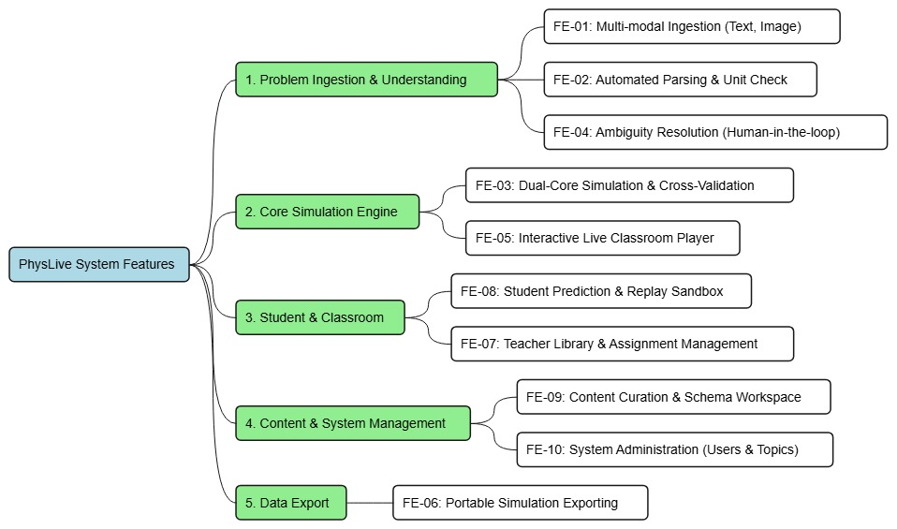
Figure 1.Mind Map

6.2 Minimum Requirements (Core MVP Baseline & Acceptance Criteria)
To guarantee rigorous academic evaluation, mitigate implementation risks, and align strictly with capstone defense criteria, the project explicitly demarcates the Minimum Viable Product (MVP) requirements from the extended production scope. While the full platform encompasses enterprise-grade B2B governance and continuous reviewer auditing, the Core MVP Baseline represents the indispensable pedagogical and technical foundation required for successful platform delivery and academic acceptance.
A. Baseline Minimum Requirements (Core MVP Scope):
MR-01: Multimodal Problem Ingestion & Semantic Parsing (FE-01, FE-02, FE-04): Automated ingestion of natural-language or image-based textbook problems via OCR and LLM; extraction of physical quantities, initial states, boundary conditions, and SI unit consistency checks; interactive ambiguity resolution prompting users when parameter under-specification is detected.
MR-02: Verifiable 2D Physics Simulation (FE-03, FE-05): Execution of adaptive RK4 numerical solvers verified against domain physics laws, coupled with real-time 2D canvas rendering at 60 FPS; interactive student playback controls (play, pause, step, simulation speed) with real-time parameter tweaking sliders and dynamic vector displays.
MR-03: Student Interactive Learning & POE Auto-Grading (FE-08): Implementation of the Predict-Observe-Explain (POE) pedagogical workflow, enabling learners to submit qualitative and quantitative predictions prior to simulation execution, followed by automated grading against verified physical simulation ground truth.
MR-04: Classroom & Assignment Management (FE-06, FE-07): Educator workflows for organizing simulations into curriculum topics, generating randomized homework variations with anti-cheat parameter seeding, and exporting standalone offline HTML bundles and printable PDF lab worksheets (via Apache PDFBox).
MR-05: Secure Authentication & Role-Based Access Control (FE-10): Stateless JWT token authentication with BCrypt password hashing; role-based access control protecting educational routes across Administrator, School Manager, Teacher, Student, and Guest personas.
B. Extended Production Capabilities (Fully Realized in Current Codebase):
ER-01: Content Curation & Physical Law Gap Auditing (FE-09): Dedicated reviewer portal for curating benchmark gold-standard simulations, auditing physical formula definitions, and automated logging of physical law violations via Flyway V51 database migration.
ER-02: Multi-Tenant Institutional B2B Management & Billing Analytics (FE-10+): Multi-school tenant isolation, monthly AI token allowance quotas, VietQR/PayOS payment synchronization, and executive financial analytics dashboard reporting revenue trends and conversion KPIs.
ER-03: Deterministic Simulation Compute Caching: High-efficiency SHA-256 parameter digest caching (ComputeResultCache) eliminating redundant solver executions across concurrent classroom sessions.
Implementation Status Verification: A comprehensive codebase audit of the active repository (FA26SE309) confirms that 100% of both the Baseline Minimum Requirements (MR-01 to MR-05) and Extended Production Capabilities (ER-01 to ER-03) are fully developed, verified by 41 automated unit tests and 31 active REST controllers, and operating stably without defect.

6.3 Limitations & Exclusions
To ensure high simulation fidelity and realistic project completion within academic timelines, the project explicitly outlines the following boundaries:
- LI-01: 2D Dimensionality Only: PhysLive strictly focuses on 2D physics representations (Mechanics, Thermodynamics, DC Circuits, Wave Optics, Oscillations). Complex 3D CAD modeling and relativistic/quantum field phenomena are excluded.
- LI-02: Internet Dependency for AI Extraction: Automated OCR and LLM-driven problem parsing require an active Internet connection to communicate with backend cloud AI providers (OpenRouter/Supabase).
- LI-03: Curriculum Scope Boundary: The initial launch catalog is tailored specifically to the Vietnamese High School Physics Curriculum (Grades 10, 11, and 12). University-level theoretical mechanics and engineering simulations are out of scope.
- LI-04: No Real-Time Hardware Sensor Integration: The platform operates as a virtual software sandbox and does not interface directly with external hardware microcontrollers (e.g., Arduino, Vernier sensors).
LI-05: Web-First Architecture (Native Mobile Out of Scope): PhysLive is engineered as a responsive, web-first application targeting desktop and tablet viewports to support complex multi-pane simulation layouts, parameter adjustment drawers, and real-time canvas rendering. Native mobile application binaries (iOS/Android) are intentionally designated as future post-capstone roadmap milestones.

